**IOT DEVICE INSTALLATION GUIDE**

**I. Preparation tool**

We need two software to run this application: JDK 11 and Maven

Please check on your computer was these installed yet?

***\* How to check***

Run command prompt on your computer

=> for Java: type java –version

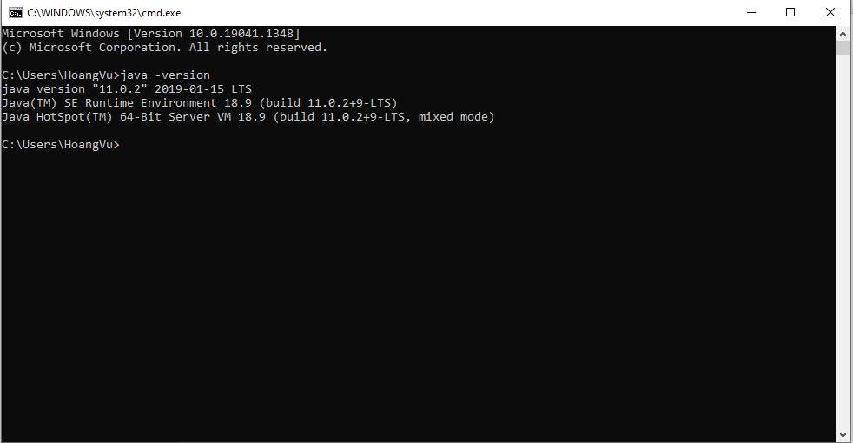

=> for Maven: type mvn –v

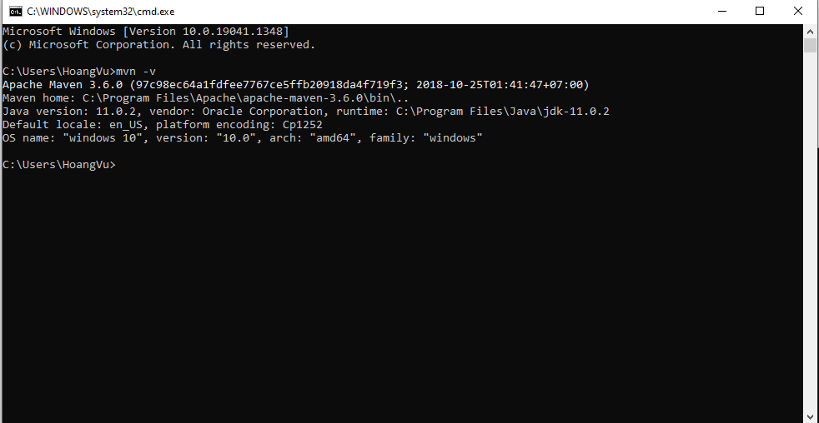

**II. Check out source code**

1. Go to this link <https://github.com/hoangvu10391/IOTDeviceWebservice.git>

2. Click on Code button and click on copy

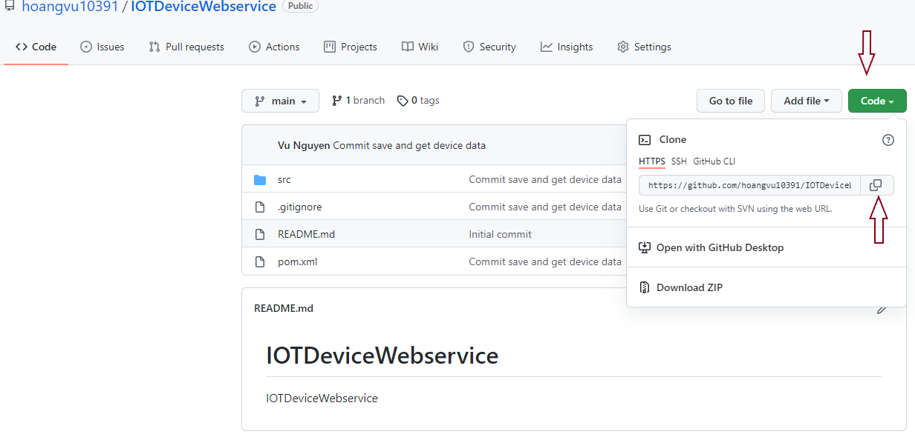

3. Navigate to the folder that you want to store source code.

Point to the address bar and type cmd => the command prompt will popup

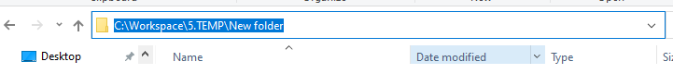

4. Type git clone and paste the github link that copied at step 2

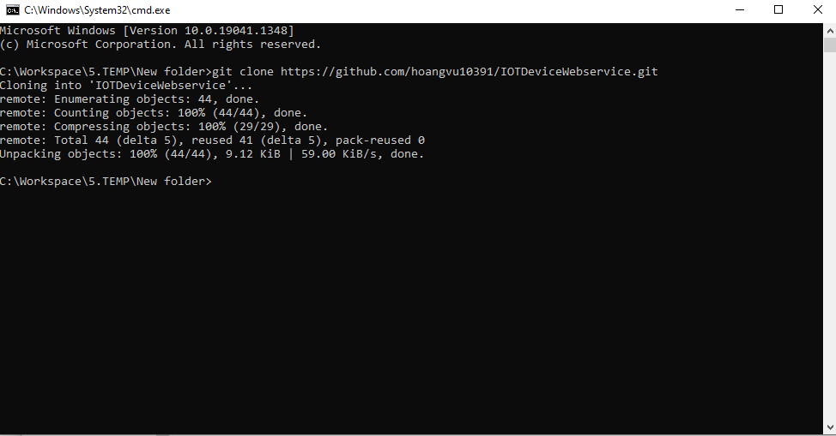

5. Check the source code, if it looks like this then you are complete checked in the latest code

**III. Build and deploy**

1. Double click on the build.bat. It will generate the target folder

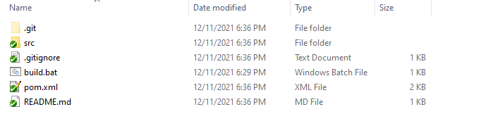

2. Change port(option)

If you want to change port then open application.properties in IOTDeviceWebservice\src\main\resources

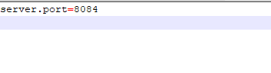

3. Go to target folder and open command prompt like step II.3

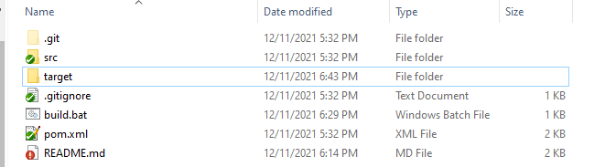

4. Type java –jar IOTDeviceWebservice-0.0.1-SNAPSHOT.jar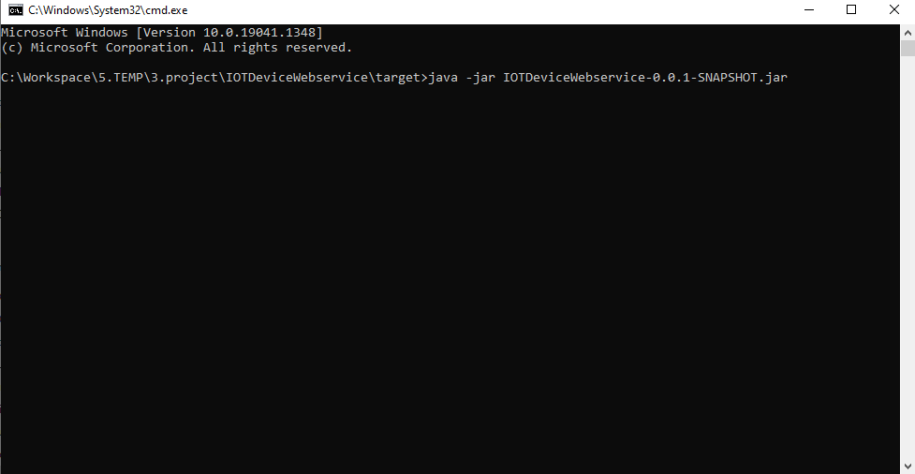

If you see this, it means the REST API complete started

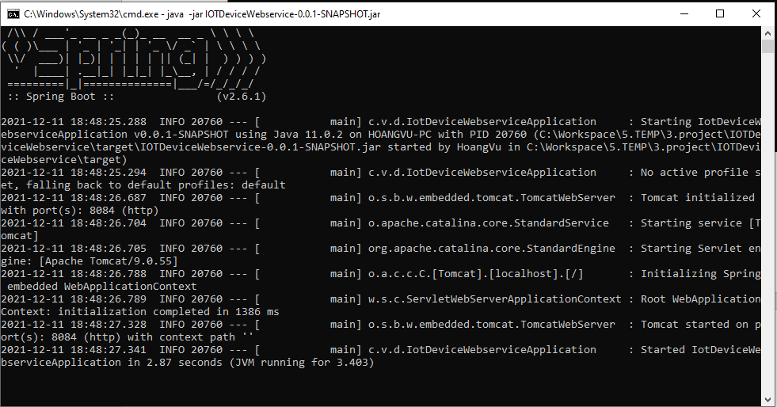

5. Now let start to test it go to this link <http://localhost:8084/api/devices/D01>

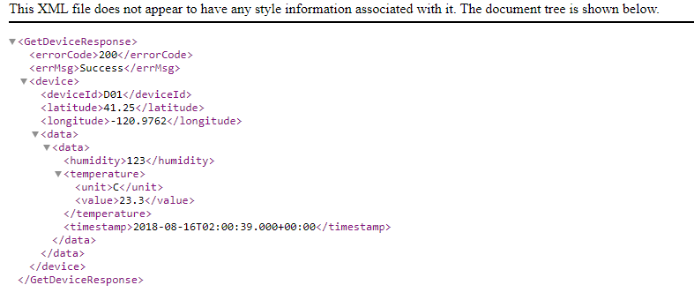

The system should return this page without any issue

Thank you for reading this guide hope that you are able to run the application.